# JS Advanced: Exam Preparation 1

**Link to contest**: <https://judge.softuni.org/Contests/3732>

# Problem 1. Hotel Reservation

**Environment Specifics**

Please be aware that every JS environment may **behave differently** when executing code. Certain things that work in the browser are not supported in **Node.js**, which is the environment used by **Judge**.

The following actions are **NOT** supported:

* **.forEach()** with **NodeList** (returned by **querySelector()** and **querySelectorAll()**)
* **.forEach()** with **HTMLCollection** (returned by **getElementsByClassName()** and **element.children**)
* Using the **spread-operator** (**...**) to convert a **NodeList** into an array
* **append()** in Judge (use only **appendChild()**)
* **prepend()**
* **replaceWith()**
* **replaceAll()**
* **closest()**
* **replaceChildren()**
* Always turn the collection into a **JS array** (forEach, forOf, et.)

If you want to perform these operations, you may use **Array.from()** to first convert the collection into an array.

**Use the provided skeleton to solve this problem.**

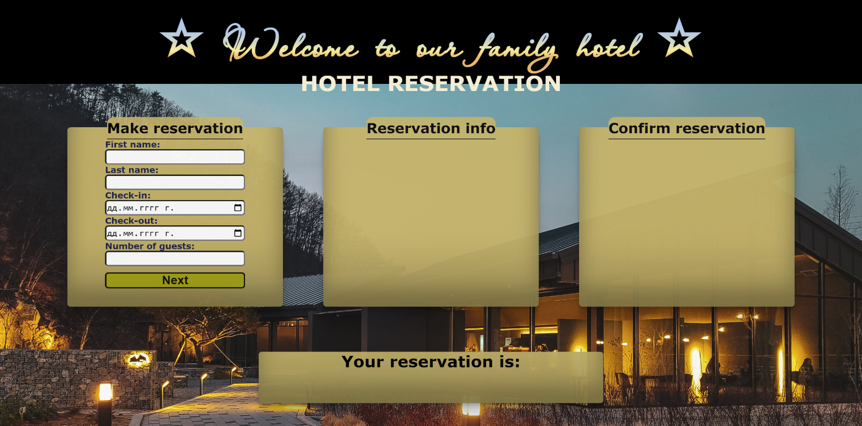**Write the missing functionality** of this user interface. The functionality is divided in the following steps:

**Your Task**

**Write the missing JavaScript code** to make the **Hotel Reservation** work as expected:

All fields **(First Name, Last Name, Check-in date, Check-out date** and **Number of guests)** are **filled with the correct input.**

* **First Name, Last Name, Check-in date, Check-out date** and **Number of guests** are **non**-**empty** **strings** and **Check-in** dateis **before Check-out** date. If any of them is empty, the program should not do anything.

## Getting the information from the form

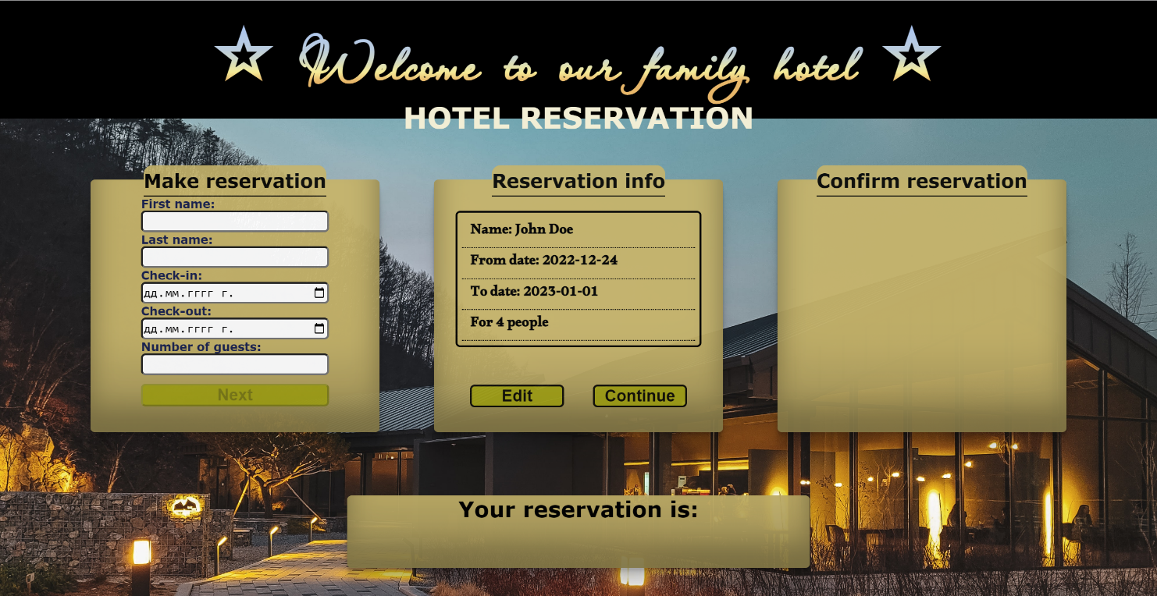

* On clicking the ["Next"] button the information from the input fields is listed in the **"**Reservation info" section. For the input fields a **list item** is **added** to the **"**info-list" unordered list.
* The text format and order for the list item should be the same as on the picture below.
* When the button is clicked, the input fields must be cleared and the ["Next"] button must be **disabled**. At the same time the "Edit" and the "Continue" buttons must be **enabled**.

The HTML structure looks like this:

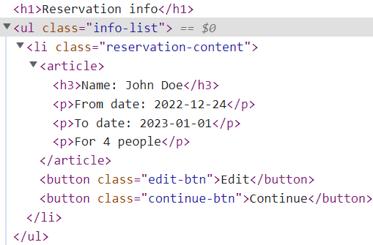

## Editing the information

**The functionality here is the following:**

* **When the "**Edit" **button is clicked, all of the information is loaded in the input fields from step 1 and the** ["Next"] **button is enabled again.**

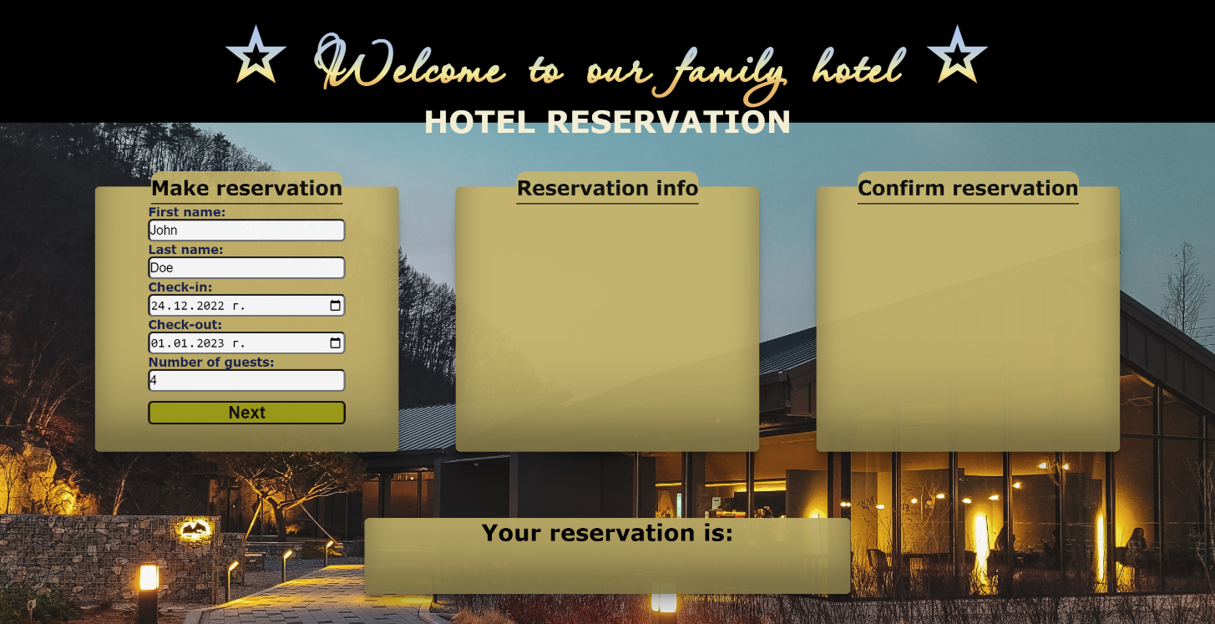

* **The list items must be removed from the** "info-list" and **all of the information must go back to the input fields again**.

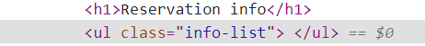

## Continues

* **When the** "Continue" **button is clicked,** **the information from** "info-list" unordered list must be transferred to "confirm-list" in the same HTML structure**. For you, this means removing everything inside of the ul with class =** "info-list" **and adding in** "confirm-list", **the list item with same information and change** "Edit" and "Continue" buttons to"Confirm" and "Cancel" with changed **class**.

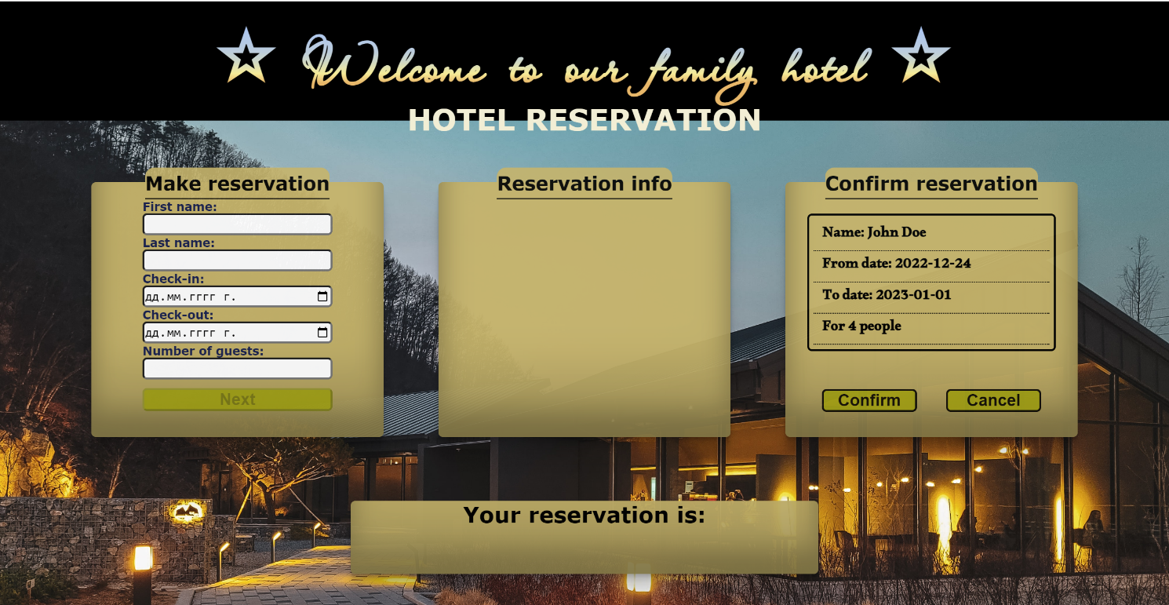

* **This is HTML** structure **of** "confirm-list" unordered list**:**

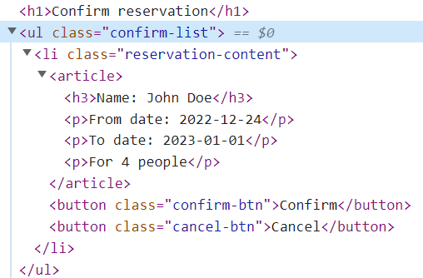

## Confirm

* **When the** "Confirm" **button is clicked,** **the list item must be removed, from the** "confirm-list", **the** ["Next"] **button is enabled again** you must add new class and add text to <h1> element with id="verification".If "Confirm" button is clicked class must be "reservation-confirmed"and text is "Confirmed.".
  + "Confirm" button:

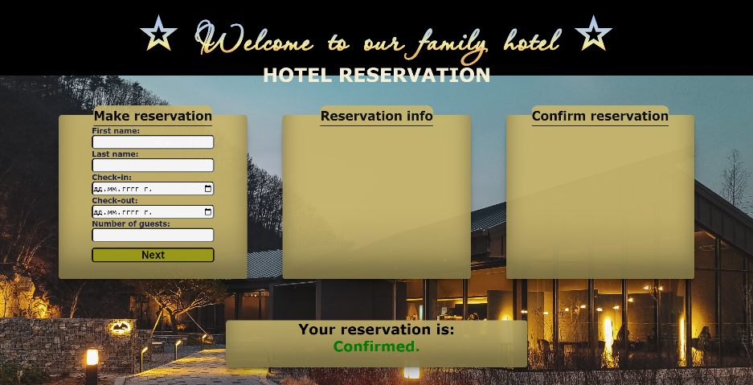

* **When the** "Cancel" **button is clicked,** **the list item must be removed, from the** "confirm-list", **the** ["Next"] **button is enabled again** you must add new class and add text to <h1> element with id="verification". If "Cancel" button is clicked class must be "reservation-cancelled"and text is "Cancelled.".
* "Cancel" button:

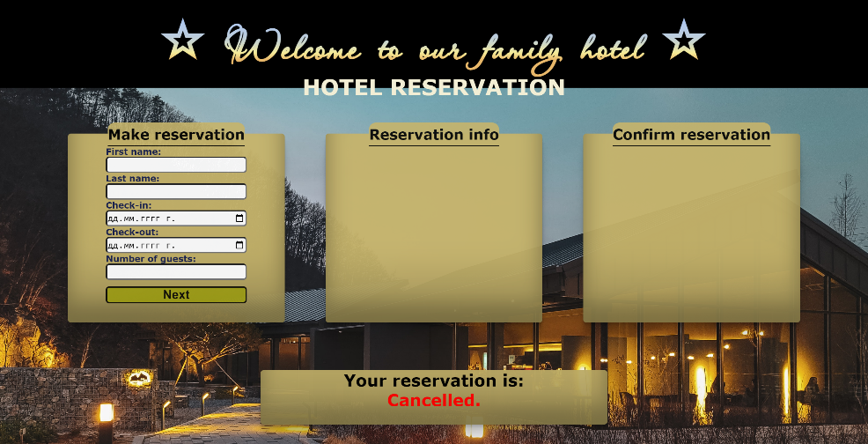

# Problem 2. OnlineShop

class OnlineShop {

//TODO Implement this class

}

Write a class **OnlineShop**, which implements the following functionality:

**Functionality**

**Constructor**

Should have these **3** properties:

* **warehouseSpace –** Number
* **products –** Array (empty)
* **sales –** Array (empty)

**At the initialization of the OnlineShop class,** the **constructor** accepts the **warehouseSpace.**

**loadingStore(product, quantity, spaceRequired)**

The **product** is of type **string**, while the **spaceRequired** and **quantity** are of type **number**.

* If there is **not enough space in the warehouse** for the new product, **throw an Error**:

"**Not enough space in the warehouse.**"

* Otherwise, this function should **add** the product with the properties: **product** and **quantity** to the products array, **reduce** the **space available** with the **space required** by the product, and **return**:

"**The {product} has been successfully delivered in the warehouse.**"

**NOTE: Product names will be unique.**

**quantityCheck(product, minimalQuantity)**

The **quantity** is of type **number**.

* If the product is not found, **throw an Error**:

"**There is no {product} in the warehouse.**"

* If the received **minimalQuantity** is **less** than or **equal** to 0, **throw an Error**:

"**The quantity cannot be zero or negative.**"

* If the received **minimalQuantity** is **less** or **equal** to the product quantity in the warehouse, **return:**

"**You have enough from product {product}.**"

* Otherwise, this function should **replace** the value of **product quantity** with a **minimalQuantity** value and **return:**

"**You added {difference} more from the {product} products.**"

* Difference is the number between the minimum quantity and the product quantity.

**sellProduct(product)**

* If the product is **not found**, throw **an Error:**

"**There is no {product} in the warehouse.**"

* Otherwise, this function should **decrement** by 1 the product quantity from the product in the products array, add it to **sales** with properties {**product}** and **{1}** for **quantity,** and **return:**

"**The {product} has been successfully sold.**"

**revision()**

This method should **return** the complete information about the shop:

* If nothing is sold, throw **an Error:**

**"There are no sales today!"**

* Otherwise, **return** how many sales you have**:**

"**You sold {sales} products today!**"

* On the second line:

"**Products in the warehouse:**"

* On the new line, display information about each product in the warehouse:

**"{product}-{quantity} more left"**

### Examples

|  |
| --- |
| **Input 1** |
| const myOnlineShop = new OnlineShop(500)  console.log(myOnlineShop.loadingStore('headphones', 10, 200));  console.log(myOnlineShop.loadingStore('laptop', 5, 200));  console.log(myOnlineShop.loadingStore('TV', 40, 500)); |

|  |
| --- |
| **Output 1** |
| The headphones has been successfully delivered in the warehouse.  The laptop has been successfully delivered in the warehouse.  Uncaught Error Error: Not enough space in the warehouse. |

|  |
| --- |
| **Input 2** |
| const myOnlineShop = new OnlineShop(500)  console.log(myOnlineShop.loadingStore('headphones', 10, 200));  console.log(myOnlineShop.loadingStore('laptop', 5, 200));  console.log(myOnlineShop.quantityCheck('headphones', 10));  console.log(myOnlineShop.quantityCheck('laptop', 10));  console.log(myOnlineShop.quantityCheck('TV', 40,)); |

|  |
| --- |
| **Output 2** |
| The headphones has been successfully delivered in the warehouse.  The laptop has been successfully delivered in the warehouse.  You have enough from product headphones.  You added 5 more from the laptop products.  Uncaught Error Error: There is no TV in the warehouse. |

|  |
| --- |
| **Input 3** |
| const myOnlineShop = new OnlineShop(500)  console.log(myOnlineShop.loadingStore('headphones', 10, 200));  console.log(myOnlineShop.loadingStore('laptop', 5, 200));  console.log(myOnlineShop.quantityCheck('headphones', 10));  console.log(myOnlineShop.quantityCheck('laptop', 10));  console.log(myOnlineShop.sellProduct('headphones'));  console.log(myOnlineShop.sellProduct('laptop'));  console.log(myOnlineShop.sellProduct('keyboard')); |
| **Output 3** |
| The headphones has been successfully delivered in the warehouse.  The laptop has been successfully delivered in the warehouse.  You have enough from product headphones.  You added 5 more from the laptop products.  The headphones has been successfully sold.  The laptop has been successfully sold.  Uncaught Error Error: There is no keyboard in the warehouse. |

|  |
| --- |
| **Input 4** |
| const myOnlineShop = new OnlineShop(500)  console.log(myOnlineShop.loadingStore('headphones', 10, 200));  console.log(myOnlineShop.loadingStore('laptop', 5, 200));  console.log(myOnlineShop.quantityCheck('headphones', 10));  console.log(myOnlineShop.quantityCheck('laptop', 10));  console.log(myOnlineShop.sellProduct('headphones'));  console.log(myOnlineShop.sellProduct('laptop'));  console.log(myOnlineShop.revision()); |

|  |
| --- |
| **Output 4** |
| The headphones has been successfully delivered in the warehouse.  The laptop has been successfully delivered in the warehouse.  You have enough from product headphones.  You added 5 more from the laptop products.  The headphones has been successfully sold.  The laptop has been successfully sold.  You sold 2 products today!  Products in the warehouse:  headphones-9 more left  laptop-9 more left |

**Problem 3. Unit Testing**

**Your Task**

Using **Mocha** and **Chai** write **JS Unit Tests** to test a variable named **MotorcycleRider**, which represents an object. You may use the following code as a template:

|  |
| --- |
| describe(**"*Tests* …"**, **function**() {  describe(**"*TODO* …"**, **function**() {  ***it***(**"*TODO …*"**, **function**() {  *//* ***TODO:*** …  });  });  *//* ***TODO:*** …  }); |

The object that should have the following functionality:

* **licenseRestriction (category) -** A function that accepts **one** parameter: **string**.
* If the **category** is **"AM"** **return** the string:

**"Mopeds with a maximum design speed of 45 km. per hour, engine volume is no more than 50 cubic centimeters, and the minimum age is 16."**

* If the **category** is **"A1"** **return** the string:

**"Motorcycles with engine volume is no more than 125 cubic centimeters, maximum power of 11KW. and the minimum age is 16."**

* If the **category** is **"A2"** **return** the string:

**"Motorcycles with maximum power of 35KW. and the minimum age is 18."**

* If the **category** is **"A"** **return** the string:

**"No motorcycle restrictions, and the minimum age is 24."**

* If the value of the string **type** is different from "**AM,A1,A2,A**", **throw** an error:

**"** **Invalid Information!"**

* **motorcycleShowroom** **(engineVolume, maximumEngineVolume) -** A function that accepts an **array** and **number**. The **engineVolume** array will store the engine volume of a motorcycles in cubic centimeters (["**125**", "**250**", "**600**"…]), you need to check every element in the array and if its **less** or **equal** to **maximumEngineVolume**.
  + You must **add** an **element** (engineVolume)if **maximumEngineVolume** is **less** or **equal** to **engineVolume** from the **array** in to new **availableBikes array**.
  + Finally, **return** the array length in following string:

**"There are ${availableBikes.length} available motorcycles matching your criteria!"**

* + There is a **need for validation** for the input, an **array** and **number** may not always be valid. In case of submitted **invalid** parameters, **throw** an error **"Invalid Information!"**:
    - If passed **engineVolume** or **maximumEngineVolume** parameterare not an **array** and **number**.
    - If the **engineVolume** is an empty array, and if **maximumEngineVolume** is **less** than **50.**
* **otherSpendings (equipment, consumables, discount) -** A function that accepts three parameters: **array, array** and **boolean**.
* Calculate the **total price** you are going to pay depending on the purchased **equipment** and **consumables:**
  + - **The result must be formatted to the second digit after the decimal point.**
* The bike shop offers **two** options for **equipment** and **consumables**:
  + - The two options for **equipment** are:
      * **helmet,** which costs **$200**
      * **jacked,** which costs **$300**
    - The two options for **consumables** are:
      * **engine oil**, which costs **$70**
      * **oil filter**, which costs **$30**
* If the **discount** is **true,** **10%** discountshouldbeapplied**.** Then **return** the following message:

**"You spend $${totalPrice} for equipment and consumables with 10% discount!"**

* Else, **return** the following message:

**"You spend $${totalPrice} for equipment and consumables!"**

* You need to validate the input, if the **equipment, consumables** and **discount** are not a **array, array** **and** **boolean** an error: "**Invalid information!**"

**JS Code**

To ease you in the process, you are provided with an implementation that meets all of the specification requirements for the **MotorcycleRider** object:

|  |
| --- |
| chooseYourCar.js |
| const motorcycleRider = {    licenseRestriction(category) {      if (category === "AM") {        return 'Mopeds with a maximum design speed of 45 km. per hour, engine volume is no more than 50 cubic centimeters, and the minimum age is 16.'      } else if (category === "A1") {        return 'Motorcycles with engine volume is no more than 125 cubic centimeters, maximum power of 11KW. and the minimum age is 16.'      } else if (category === "A2") {        return 'Motorcycles with maximum power of 35KW. and the minimum age is 18.'      } else if (category === "A") {        return 'No motorcycle restrictions, and the minimum age is 24.'      } else {        throw new Error("Invalid Information!");      }    },    motorcycleShowroom(engineVolume, maximumEngineVolume) {      if (!Array.isArray(engineVolume) || typeof maximumEngineVolume !== "number" || engineVolume.length < 1 || maximumEngineVolume < 50) {        throw new Error("Invalid Information!");      }      let availableBikes = [];      engineVolume.forEach((engine) => {        if (engine <= maximumEngineVolume && engine >= 50) {          availableBikes.push(engine);        }      });      return `There are ${availableBikes.length} available motorcycles matching your criteria!`;    },    otherSpendings(equipment, consumables, discount) {      if (        !Array.isArray(equipment) ||        !Array.isArray(consumables) ||        typeof discount !== "boolean"      ) {        throw new Error("Invalid Information!");      }      let totalPrice = 0;      equipment.forEach((element) => {        if (element === "helmet") {          totalPrice += 200        } else if (element === "jacked") {          totalPrice += 300        }      });      consumables.forEach((element) => {        if (element === "engine oil") {          totalPrice += 70        } else if (element === "oil filter") {          totalPrice += 30        }      });      if (discount) {        totalPrice = totalPrice * 0.9;        return `You spend $${totalPrice.toFixed(2)} for equipment and consumables with 10% discount!`      } else {        return `You spend $${totalPrice.toFixed(2)} for equipment and consumables!`      }    }  };      }  } |